PNIN Solution Device Requirements

Problem Description:

Our device aims to help people with a very common medical condition known as foot drop.

***Foot drop*** (AKA drop foot), is a medical condition that affects the ability to lift the front part of the foot, causing it to drag or slap on the ground while walking. It is caused by the weakness or paralysis of the muscles that are responsible for ***dorsiflexion*** of the foot, which means lifting the foot upwards towards the shin. The ***anterior tibialis* *muscle*** is innervated by the ***peroneal nerve***, which runs from the spinal cord down the back of the leg and branches out to supply the muscles of the lower leg and foot. Any injury that could occur to this nerve can cause a case of drop foot.

Solution Device Overview:

Our proposed solution for foot drop is a ***compact, battery-powered*** device that is anchored below the knee. This device is designed to accurately detect the position of the patient's ***gait cycle*** while walking using an appropriate ***sensor*** and then send an electrical pulse, known as a ***Functional Electrical Stimulation (FES)*** pulse, to the peroneal nerve through ***electrodes***. This FES pulse stimulates the anterior tibialis muscle, preventing the foot from dropping and promoting proper foot and leg movement.

Here's how the device could look like:

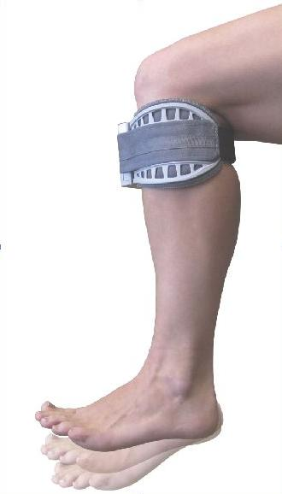 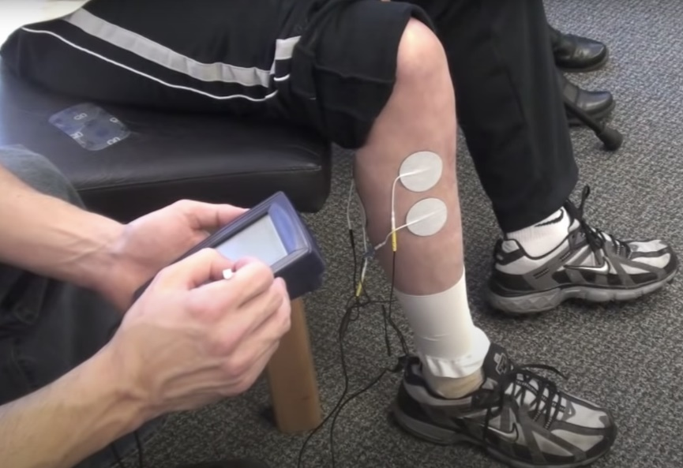

Electrical Requirements:

1. Input:

The main input for the device is a sensor or multiple sensors that should be able to accurately (very accurately) detect the position of the patient’s leg at the gait cycle in order to know when to activate the muscle and when not to (Ex: IMU sensor, Flex Sensor …). There will be of course addition buttons and potentiometers to adjust the settings of the device as described below.

1. Output:

The output from the device would be an electrical pulse sent to the peroneal nerve at the correct time during the gait cycle in order to activate the tibialis muscle and prevent the foot from dropping. This electrical pulse would be in the form of FES pulse and therefore should follow all FES rules in the scientific literature and publications (Type of waveform, voltage range, current range, …) It’s also worth noting that this device could be used by any patient regardless of age, gender, severity of case, … So, it should be very dynamic in the voltage and current range (ex: using potentiometers and/or push buttons to adjust the settings based on the patient’s needs). The device should also contain a small screen to display the current settings of the device and other useful information.

1. Microcontroller:

There’s no specific type of microcontroller required.

1. Power:

The device is battery powered and it’s expected to last at least a full day of continuous use by the patient before being recharged again (so around 16 hours of battery life). Commercial AA or AAA batteries are recommended for the design of the device; however, we can use other types of batteries (NiCad, NiMH, Lithium batteries …) if needed (with the appropriate circuit standards and protections of course.

1. Connectivity:

The device should be able to connect to smartphones using Bluetooth.

1. Others:

LED On Indicator, LED Low Battery Indicator,

Mechanical Requirements:

Since the device is wearable below the knee, it has to be as compact and lightweight as possible. We expect the device to not exceed the following parameters:

Weight (with batteries): 250~300 grams

Dimensions: 8cm x 8cm